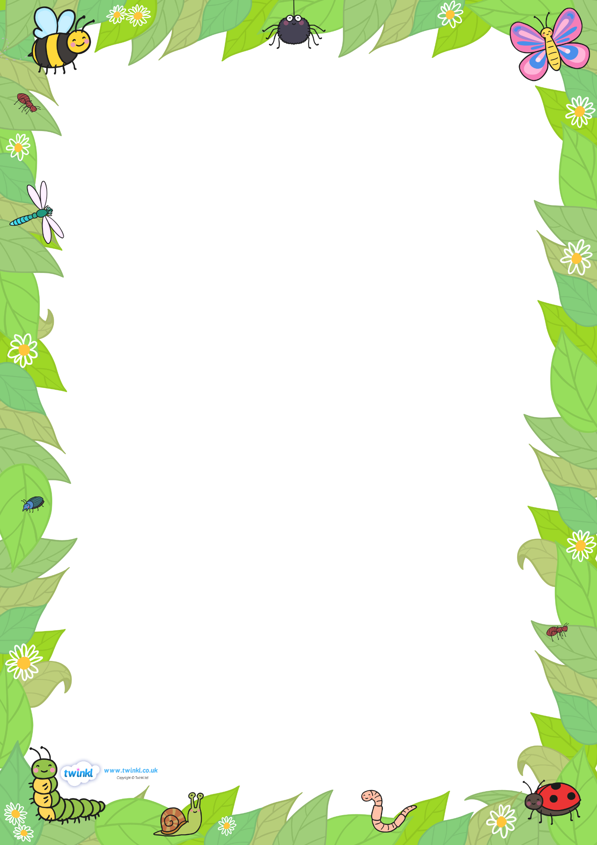
Draw all of the mini-beasts you can think of and label each one.

