Story Writing- River Narrative
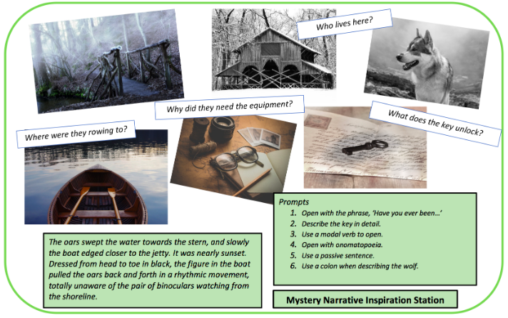
Ideas
Success Criteria:
Ambitious, precise vocabulary
Varied sentence openers and lengths
Use senses to describe
Accurate punctuation
Similes and personification
Dialogue
Rhetorical question
Repetition- power of three.

Third person narrative, ending on a cliff-hanger with questions unanswered. Descriptive writing!

5 plot points (each forming a paragraph). These can be changed- they are just an idea!

- River setting- senses (sights, sounds), feeling of being watched, description of boat.
- Stepping onto dry land and crossing a bridge.
- Finding key- by pulling key out of pocket? Lying on the ground? In the lock of the building? Description of the key.
- Entering the building- description, action and dialogue. Do we meet another character?
- Cliff hanger- action, suspense, finding something?

Day 1- Plan each paragraph. Think about the vocabulary you might use and the content of each. How might you build suspense with action and description? Don’t write the full story, just plan with spider diagrams or words and phrases.
Day 2

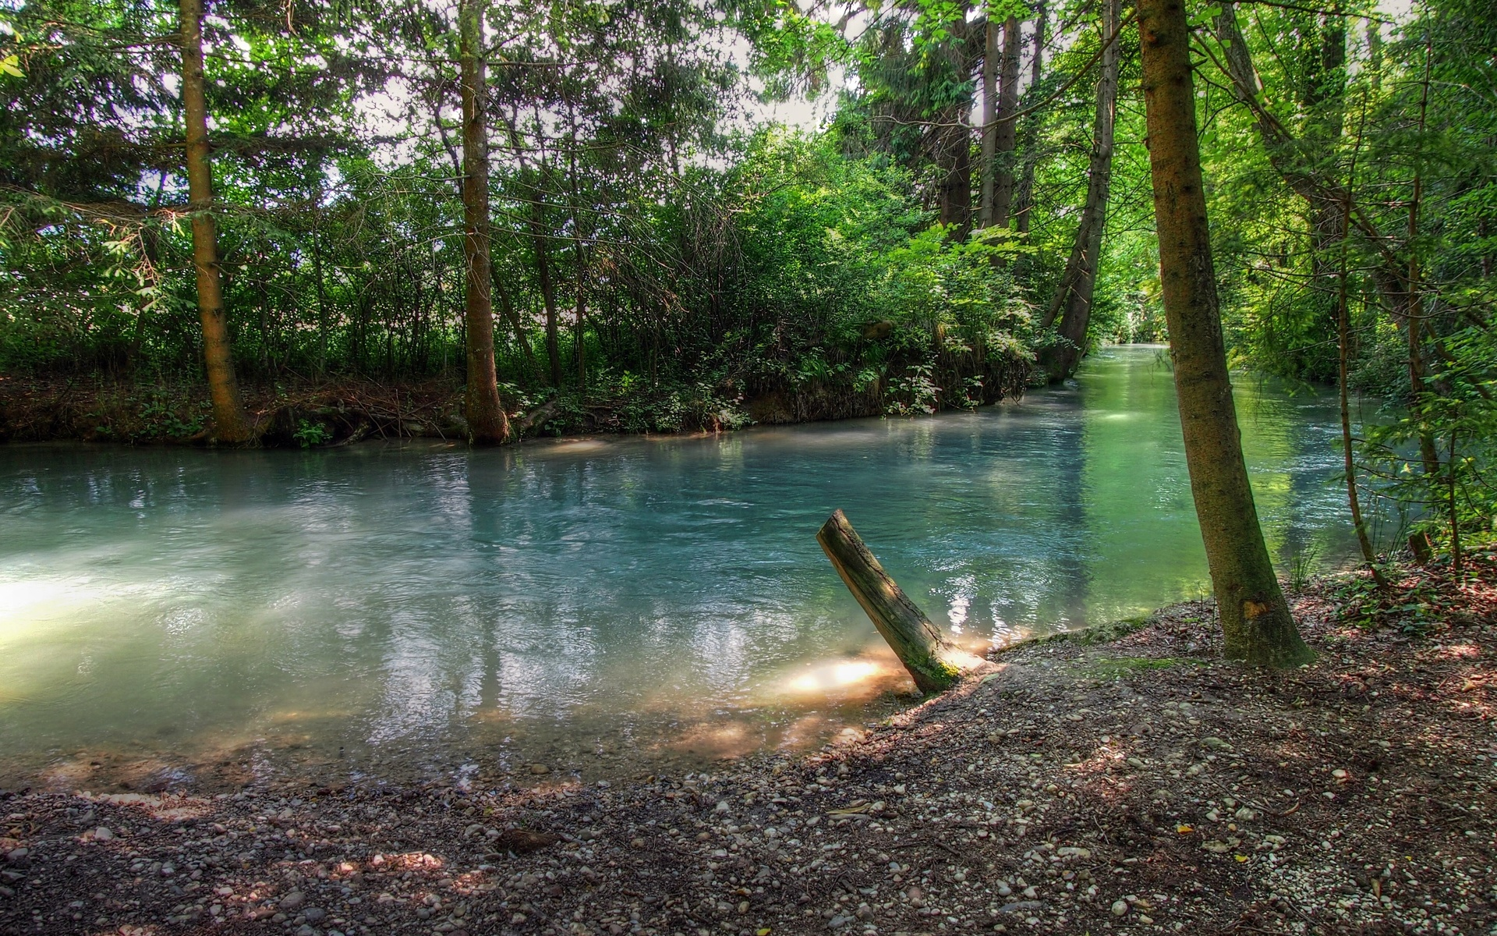

Focus on writing your river setting. Draft and then edit until you are happy with your opening paragraph.

Start by improving these sentences. They might inspire some ideas for your paragraph?

- The river flowed between the overgrown trees.

- The sun reflected off the surface.

- The riverbank beckoned the cloaked figure.

- The murky water lapped up the side of the boat.

- Sounds echoed in the distance.

Success Criteria:
Ambitious, precise vocabulary
Varied sentence openers and lengths
Use senses to describe
Accurate punctuation
Similes and personification
Dialogue
Rhetorical question
Repetition- power of three.

Day 3- Story draft and edit

Use your plan to draft out the remaining paragraphs.
Check the success criteria.
Read your story aloud.
Have you used your senses to describe?
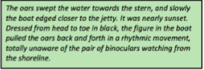
How can you make the reader want to discover more?



Idea: a third person descriptive story, like the example below.

