Lesson 4
Fact File

To create a fact file, you are going to use some of the information that you put in your character description on the previous lesson, however it will be in more detail. Your bingo boards will come in very useful for this piece of writing! Include the subheadings that are in the example below.

Success Criteria
- Title (underlined)
- Introduction
- Subheadings (underlined)
- Lots of detail
- Fact box

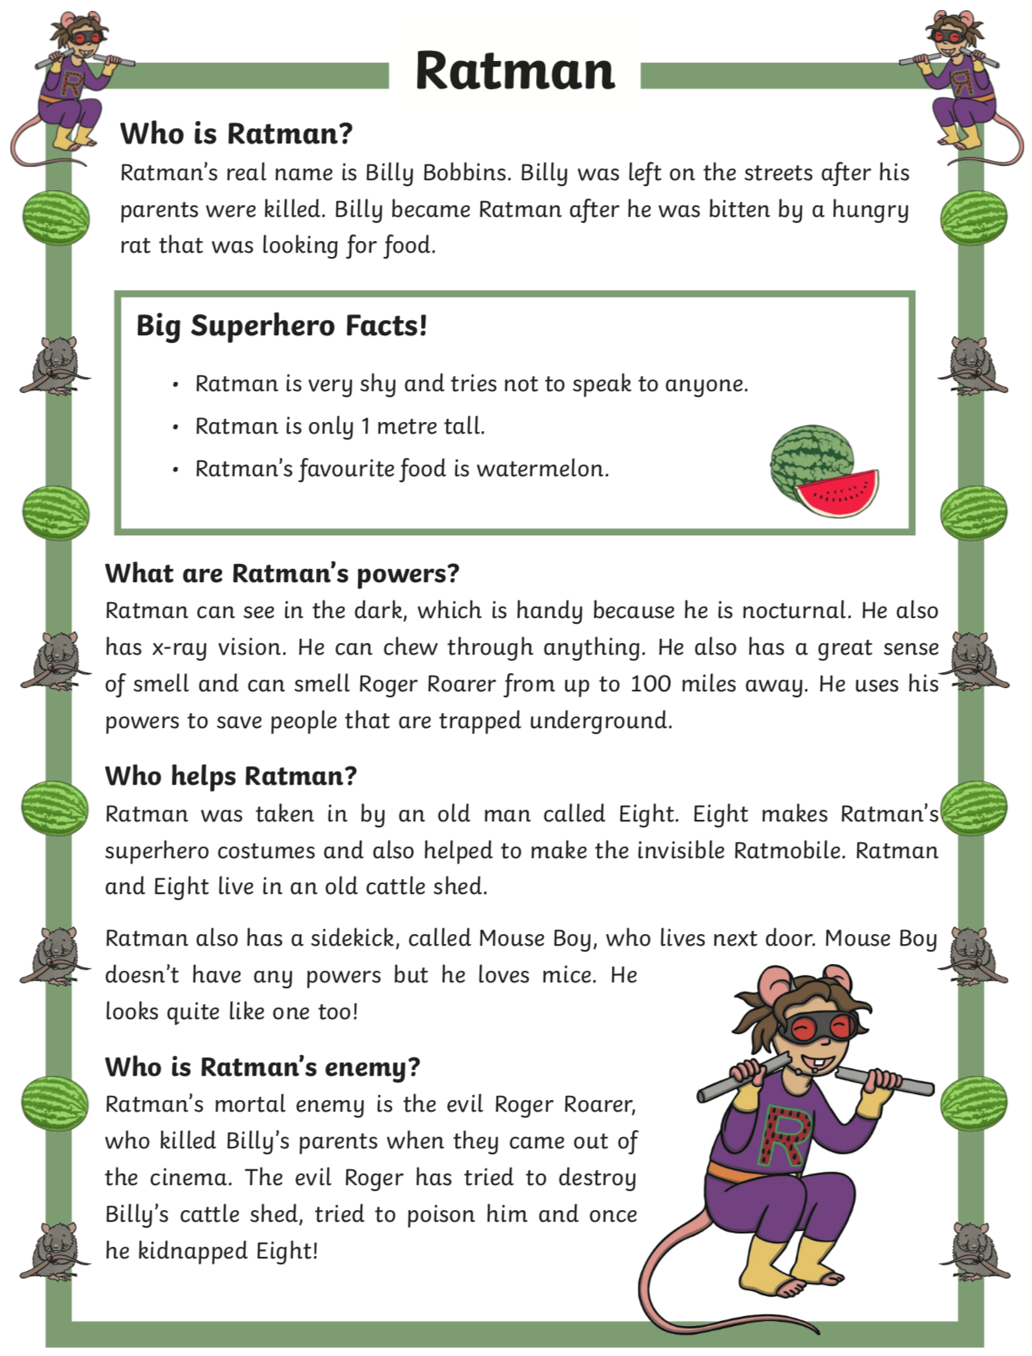
Edit and improve - Check your writing at the end to see if you have included capital letters, full stops, correct spelling and see if it makes sense.

