Lesson 4
Subtraction – Written Methods

As well as adding 2 two digit numbers, in Year 2 the children need to be able to subtract 2 two-digit numbers. When using subtraction, we always start with the biggest number. Similar to addition, we encourage the children to subject the tens number first and then the ones number.

For example:
46 – 23 =
46 – 20 = 26
26 – 3 = 23

The worksheet has some calculations with space for your child to work out the answers and some reasoning questions based on subtraction. Answers will be provided. You could even set your child some easier/harder questions if you wish.

66 - 32 =

24 - 23 =

77 - 45 =

58 - 41 =
85 - 52 =

84 - 21 =

45 - 33 =

96 - 54 =

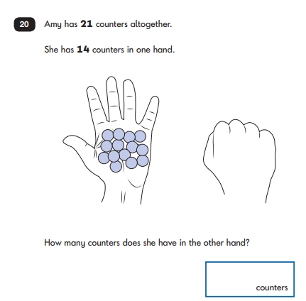
Reasoning
