Lesson 3
Addition – Written Methods

In Year 2 it is important that children are able to add 2 two-digit numbers. The children have learnt some different methods (adding tens then ones, drawing dienes, number lines) and can choose their preferred way to solve different calculations. We encourage the children to always add the tens number first in case the answer crosses over the next ten, for example, 27 + 16.

The worksheet has some calculations with space for your child to work out the answers and some reasoning questions based on addition. Answers will be provided. You could even set your child some easier/harder questions if you wish.

Challenge: If you feel that your child is ready, they could try adding a two-digit number to a three-digit number (e.g. 152 + 46).

Arithmetic

36 + 21 =

23 + 24 =

47 + 35 =

58 + 41 =
18 + 47 =

21 + 18 =

31 + 15 =

55 + 26 =

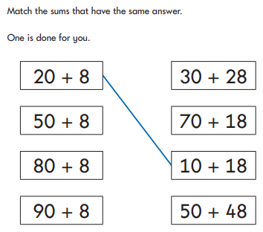
Reasoning

