Lesson 2
Number Bonds to 100

As a quick starter, practise the previous lesson’s number bonds to 20. Give your child a number and they can write/say the number bond back to you OR use the Hit the Button website to play a game.
https://www.topmarks.co.uk/maths-games/hit-the-button

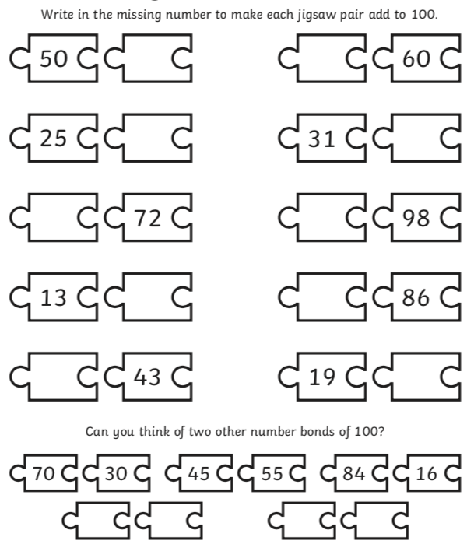
The worksheet goes through number bonds to 100.

