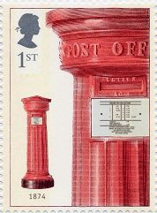

Lesson 4 – To publish my writing

Publishing your postcard from New York
Success Criteria
- Careful, accurate and realistic sketching. Remember the loose pencil grip for sketching.
- Neat, joined handwriting sat on the line.
- Capital letters, full stops and commas (after fronted adverbials and in a list)
- Apply all your corrections and edits to the finished piece.
- Do not rush.

