
Year 3 & Year 4 Writing

Lesson 3
To be able to edit and improve my writing.

Once you have finished your first draft, go back over you work and make it even better!
- Use a dictionary or the internet to check spelling mistakes.
- Check you have used capital letters and full stops correctly.
- Use a thesaurus or the internet to improve at least three words. (The synonyms may help)
- Change one sentence.
- Add a fronted adverbial in.
- Add an extra sentence.

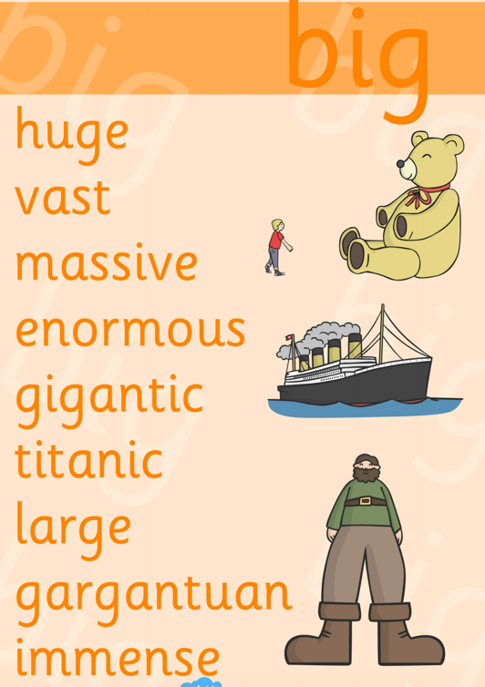
Remember its ok for your work to look untidy, it is a first draft and the best authors are always changing and editing their writing.

